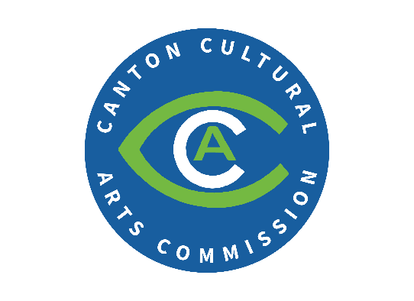
Public Arts Grant Parameters
Administered by the Canton Cultural Arts Commission (CCAC)
Purpose:
The purpose of the CCAC Public Arts Grant Program is to highlight public art opportunities in the City of Canton through grants and technical assistance as these projects build community, create a sense of place, and boost economic development and tourism initiatives.

Parameters:
Public art is a valuable and meaningful component in many tenets in the City of Canton’s Roadmap for Success.
Public arts may include murals, sculptures, creative use of sound or light, and activities related to cultural arts. Applicants must submit design concepts, budget estimates, and information related to the location and availability of the work.
Funds during the initial grant period shall be decided on a competitive basis by the CCAC.
Matching grants require dollar for dollar expenditure by the owner/tenant. Grants of varying amounts up to $10,000 can be awarded for public arts projects. The CCAC reserves the right to grant additional money to public arts projects they believe will have significant impact on the area. The CCAC reserves the right to deny applications or to issue awards in lesser amounts.
Tenants may qualify for grant funds with written consent of the building owner.
No work being considered for a grant should begin until authorized by the CCAC through an approved application and any required certification process.
Where practical, all historic building facades shall adhere to their original period design or adhere to current Canton Historic Preservation Commission (HPC) guidelines or design aspects approved by the HPC. Canton Cultural Arts Commission provides final approval of grant application upon receipt of approval for all applicable structures governed by the Canton HPC.
No grant funding or matches shall be used to perform general repair, structural, or habitable work or otherwise to meet code to occupy the building.
Work completed by the applicant requires a detailed budget including artist fees, supplies, and installation costs. Additionally, CCAC desires a release from the artist to be able to reproduce the work for marketing purposes.
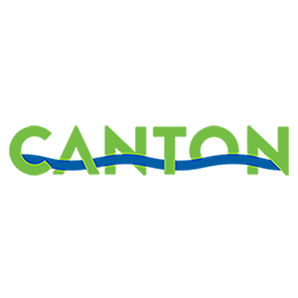
Final cost receipts must be provided by the applicant upon project completion to verify final grant proceeds. All approved work must be completed within 90 days unless another timeline is agreed upon by CCAC and applicant. Approved projects must remain in place for an agreed upon time frame as part of the grant approval process.
Application Process:
To qualify for grant funds, an application and appropriate plans must be submitted to Kristin Norton via email at Kristin.Norton@cantonga.gov.

