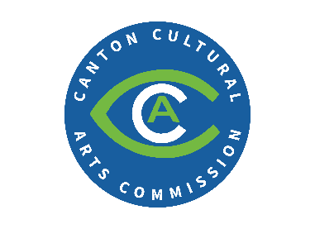
Public Arts Grant Program
Administered by the Canton Cultural Arts Commission

Grant Procedures
- Complete required application.
Pending a pre-approval of the project by the Canton Cultural Arts Commission, the applicant will be asked to assist in filling out paperwork necessary to achieve a certificate of appropriateness from the Historic Preservation Commission.
- Please provide a photo of the area for the installation. Please describe the existing area where the work will occur, including any existing materials or structural elements that may need to be altered for the installation.
- Projects not requiring the approval of the Canton Historic Preservation Commission require only the Public Arts Grant Program application, approval by City of Canton building department (building official/fire inspector) as needed, accompanying budget or cost breakdown, and a full description of the project.
- Once all approvals have been met, written notice will be delivered to applicant, and work can begin. No work should start until written notice is received by applicant.
- Applicant is responsible for obtaining any permits required for execution of project. Any fees associated with projects pre-approved by the Canton Cultural Arts Commission will be waived by the City.
- Upon project completion, CCAC will reimburse applicant for approved public arts project costs as agreed upon. The CCAC and applicant will agree on a minimum amount of time project must displayed.
- Applicant must submit a paid bill for reimbursement together with an affidavit from the artist certifying work completion as approved. Any unapproved changes will void the Grant. If applicant changes the project after approval, they must contact CCAC.
The Canton Cultural Arts Commission reserves the right to grant additional money to targeted public arts projects they believe will have significant impact on beautification, economic development, and community building in the City. City of Canton staff will be available as needed to assist and may seek outside guidance on complex projects. CCAC may deny applications.
All applications are contingent on funding and can be tabled until such time as funds are available.
