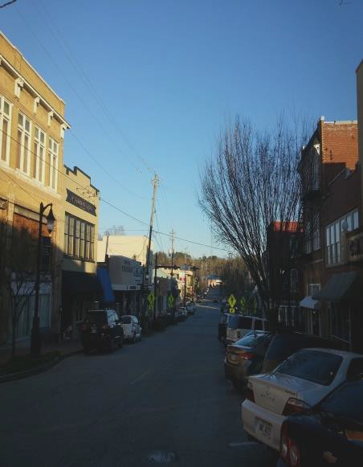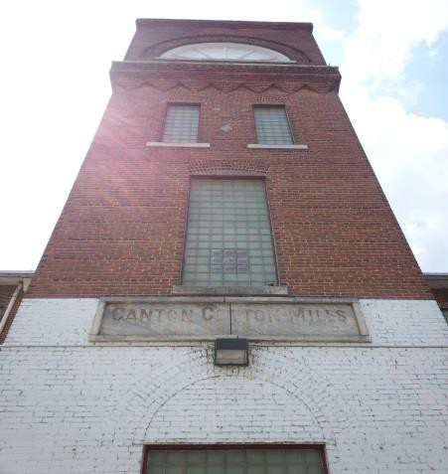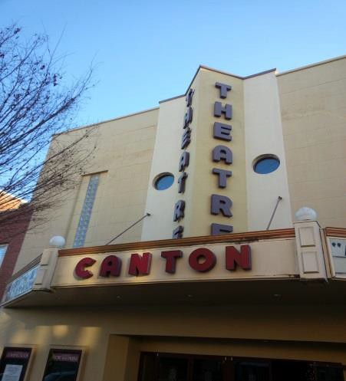


CENTRAL CANTON
URBAN REDEVELOPMENT
PLAN

April 2023

Prepared by:
CITY OF CANTON
CENTRAL CANTON
URBAN REDEVELOPMENT
PLAN

April 2023

Prepared by:
City of Canton Community Development Department

April 2023

Prepared by:
City of Canton Community Development Department

Table of Contents
CENTRAL CANTON URBAN REDEVELOPMENT PLAN 0
Introduction 2
Perspective on Canton 2
Canton Roadmap for Success 5
Central Canton 6
Background 6
Purpose and Intent 6
Vision 6
Objectives 7
Boundaries of the Redevelopment Area 7
Negative Conditions within the Redevelopment Area 9
Economic Outlook 24
Consistency with Adopted Plans 34
City of Canton Comprehensive Plan 34
Comprehensive Plan Vision 34
Description of Character Areas and the Development Strategy for Each 34
City of Canton Overlay Zone Community Standards Ordinance 38
Technology Ridge Opportunity Zone 38
River Mill Livable Centers Initiative Enterprise Zone 39
Goals and Strategies for Central Canton 40
Community’s Future Land Use Objectives 45
Impacts of the Redevelopment Plan 45
Description of Parcels to be Acquired 45
Structures to be Demolished or Rehabilitated 45
Strategy for Relocating Displaced Residents 45
Covenants and Restrictions to be placed on Properties 46
Plan to Leverage Private Resources for Redevelopment 46
Opportunity Zone 46
Needed Public Infrastructure 46
Strategy for Implementing the Plan 46

INTRODUCTION

Perspective on Canton

The discovery of gold in 1929 at Dahlonega created a rush into northern Georgia and the demise of the Cherokee Nation as Georgia created Cherokee County in December 1831. The modern Cherokee County was first surveyed in 1832 and the county seat, originally named Etowah, was established in 1833. When it was determined that there was no gold on many of the 40-acre lots created by the survey, a silk production venture came to the area, and the county seat was re-named Canton in 1834.
When silk production proved a failure, cotton and tobacco became the primary crops for the area until the railroad was extended to Canton from Marietta and Atlanta in 1879. The advent of rail access allowed cotton and the small but thriving marble industry to ship their goods south to Atlanta and Marietta in When the 1880s, and Canton was transformed into an industrial city when R.T. Jones and other investors established the Canton Cotton Mill in 1899. The mill quickly became the largest employer in the county, and the center of economic and social life in the city. The mill built two villages to house its employees, established schools, sponsored festivals, operated stores and built a church. In 1924, Canton Cotton Mill No. 2 was constructed, and Canton became a major center for the manufacture of denim cloth. The city became famous worldwide for the high-quality denim produced by Canton Cotton Mills.
The growth of chicken production replaced cotton as the number one agricultural product, and with the marble finishing business in the northern end of the county, and the construction of the Bell Bomber Plant, now Lockheed-Martin in Marietta, numerous opportunities for gainful employment became available by the middle of the twentieth century. In 1963, workers at the canton Cotton Mills voted in a labor union for the first time, and the mills began a slow decline with years of conflict between the workers and the mill owners (still led by members of the Jones family as majority stockholders). This conflict and other changes in society quickly eroded the familial tradition of the mill community, and the Canton Cotton Mill closed in 1981.
Canton and Cherokee County have continued to grow and thrive as the county became a bedroom community for the northern Atlanta Region. The City of Canton has been able to capture a significant amount of the regional growth in Cherokee County providing a center for government, finance, business, health care, education and local cultural resources as the county grew. The construction of Interstate 575 provided easy, albeit at some peak times congested, accessibility to the rest of the Atlanta Region. By the first decade of the 21st Century, Canton offered a combination of accessible and attractive employment opportunities, small town charm, and family-oriented services that spurred very rapid growth and development.

Over the past 30 years, the City of Canton and Cherokee County have undergone a transformation from a primarily rural county with town center to a full-fledged Atlanta suburb because of proximity to jobs, its abundance of vacant land and availability of affordable housing stock. This change has translated into significant population growth from 141,903 people in 2000 to 265,274 in 2020(U.S. Census) for Cherokee County. During this same time period, the City of Canton has grown from a population of 3,601 (1980) to 33,382 (2020, US Census). The City of Canton’s population is projected to increase to 51,745 (Ross & Associates) by 2040.

The current economic conditions have certainly slowed growth for the moment but the population and employment are still expected to increase significantly over the next ten to twenty years.

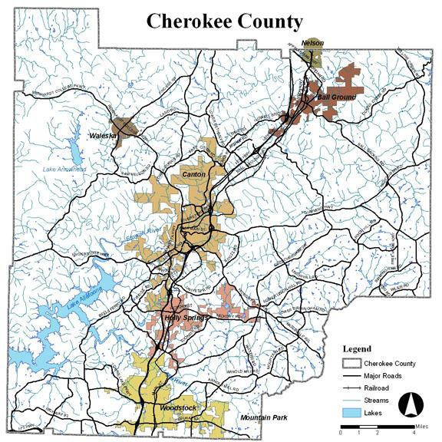

The City of Canton and Cherokee County are rich with natural resources. The Etowah River and Little River supply water to Lake Allatoona in the Southwest corner of the county. This lake is operated by the U.S. Army Corps of Engineers for flood control, power generation, water supply and recreation. Lake Arrowhead, west of Waleska, is a private lake within the Lake Arrowhead master-planned development. The NW corner of Cherokee County is the most mountainous with several recognized peaks above 2200 ft. The Etowah River bisects the City of Canton from the northeast to the southwest on its way to Lake Allatoona.

Served by excellent Interstate roadways, the Georgia Northeastern Railroad, and the Cherokee County Regional Airport, residents and businesses have convenient and efficient access to multiple modes of transportation. The Canton and Cherokee County are bisected by Interstate 575, which runs from Marietta north, ending at the Pickens County line into Georgia 515. The Georgia Northeastern Railroad operates freight service on the former L&N tracks, roughly parallel to this route. The expansion of the Airport is underway as a result of a groundbreaking federal-state-local partnership. This $25 million dollar project is an opportunity to attract significant economic development around the airport and link it to the Bluffs of Technology Park in the City of Canton, which is designed to create a major regional employment center along I-575 between Canton and Ball Ground. Population growth followsthe same general pattern as well, with new suburbs in the south following the highway toward rural areas further north.

The majority of residential development in the City of Canton has been, and is anticipated to be single-family residential units at a variety of prices and sizes. This attracts a mix of younger family households with children, first time homebuyers, and opportunities for move- up and, to a much lesser extent, executive housing in a suburban setting. Density is increasing in the cities where services exist and a more “urban” character is developing. With this dramatic household growth has come support for a significant amount of new local-serving retail and local-serving office development of moderate to high quality. Most commercial centers are clustered in Canton and Woodstock and along I-575.

Canton Roadmap for Success

Tenets

Creating Great Neighborhoods
Safe, attractive, connected, and inviting neighborhoods are the foundation of Canton’s hometown appeal. All residents deserve quality housing that reflects our community character through thoughtful design and responsible development practices.
Celebrating the Diversity of Our Community
The diverse cultures and communities within Canton are vibrant and engaging. Economic, cultural, and social diversity is encouraged throughout the City.
Advancing Regional Economic Success
Utilizing existing business strengths in industry, healthcare, and an entrepreneurial spirit, Canton seeks to expand its economic footprint. Diverse and innovative business growth will support jobs, attract investment, and create tourism opportunities.
Enhancing Historic Downtown Canton
Preservation, entrepreneurship, arts and culture, and community-centric activities are cornerstones of economic development within Downtown Canton. Benefiting the entire City, downtown redevelopment creates jobs, attracts investment, increases property values, and generates tourism.
Sustaining Our Natural Environment
Canton residents appreciate our natural beauty, proximity to the mountains, ample green spaces, and the Etowah River. Projects in the City will promote interaction with nature through sustainability, stewardship of resources, and innovative design.
Connecting Citizens to Parks and Recreation
A healthy community provides access to nature. Residents should be connected with local parks through trails, sidewalks, and additional transportation options. Recreational opportunities should be available to and inclusive for all.
Improving Infrastructure for Future Demands
Citizens, businesses, and visitors need access to the Canton infrastructural network to succeed in their goals. Transportation, power supply, gas availability, water and sewer, and digital connectivity are part of building a great network for success.
Leading with Excellence
City Council, Staff, and Citizen Boards will foster civic participation and serve ethically, transparently, responsibly, and efficiently.

CENTRAL CANTON

Background

Canton’s Central Canton Urban Redevelopment Area includes the historic commercial and institutional downtown, close-in residential, and industrial-related land uses along the railroad corridor, all nestled in a bend of the Etowah River. The Central Canton Urban Redevelopment Area includes the greatest mixture of diverse land uses within any one-character area type in the Canton 2040 Plan. The Central Canton Urban Redevelopment Area primarily consists of the Historic Canton, Central City and New Town Character Areas. The historic downtown core area of Canton is configured in a loose grid system with Main Street and North Street as a one-way pair of streets providing east/west circulation along a ridge line through the urban core. Steep slopes provide a transition between the center of the city on top of a hill and the industrial and recreation uses along the river. Access is limited by the river to the north and west, Canton Creek to the south, and the narrow, but very scenic and East Main residential corridor to the east. The character of the area is dominated by the downtown commercial and local government (City and County functions) in the core, and industrial-related land to the west along the river corridor. The area contains a variety of deteriorating and underutilized sections of downtown Canton.

Purpose and Intent

The City of Canton’s Central Canton Urban Redevelopment Plan is intended to address areas in the City’s historic, social, and cultural center that needs redevelopment. The City envisions a thriving community where the rural heritage is preserved. Central Canton hopes to offer business opportunities such as retail services, office, limited industrial and community amenities within a walkable and livable setting to its residents. The core business retail section of Central Canton was established beginning in 1899 through the 1920’s. A portion of this area is on the National Historic Register.

Vision

The Community Vision provides a general framework for the Comprehensive Plan. The following concepts from the Community Agenda shape this plan:

- Maintain the character of the community.
- Provide affordable housing and balanced land use mix.
- Create economic development opportunities.
- Protect environmental and historical resources.
- Expand and enhance community facilities and services.
- Improve the City’s transportation network for automobiles and pedestrians alike.
- Ensure that future development patterns and infrastructure are fiscally sustainable.

Objectives

The primary objectives of the City of Canton in implementing this Redevelopment Plan are to:

- Guide growth to preserve and enhance the unique character of the Central Canton Community.
- Create a walkable community through implementation of appropriate safety buffers and sidewalks widths and increasing the connectivity within the road, bicycle, and pedestrian networks.
- Remove existing blighting conditions that threaten public health, safety, and welfare.
- Provide incentives and mechanisms to promote investment in blighted and underutilized properties within the Central Canton Urban Redevelopment Area.
- Reduce crime and provide safer, cleaner, and more attractive neighborhoods and commercial areas.
- Invest in upgrading public amenities and improving obsolete or inadequate infrastructure in the Central Canton Urban Redevelopment Area.
- Spur the creation of new jobs and businesses within and in proximity to the Central Canton Urban Redevelopment Area, signifying the local government’s long-term commitment to the revitalization of the community.
- Improve the financial stability of Canton and strengthen the diversity of the tax digest.
- Remove any impediments to recruiting new industries to facilitate marketing downtown Canton as Cherokee County’s cultural, tourism, arts and entertainment center.
- Create new jobs and businesses within and in proximity to the Central Canton Urban Redevelopment Area to provide a better quality of life to local residents and particularly low-to-moderate income households.
- Meet the requirements to apply to the Georgia Department of Community Affairs for Opportunity Zone Designation.
- Increase housing options and availability of housing.

Boundaries of the Redevelopment Area

The Central Canton Area is bounded on the north by Reinhardt College Parkway, on the east the boundary is the western limit of the Riverstone mixed use development to the Etowah River to East Main Street, Muriel Street to I-575. The southern boundary of the Central Canton Urban Redevelopment Area is I-575 and the I-575 Spur Connector Road. The western boundary being Marietta Highway and Waleska Road. The Central Canton Redevelopment Area includes portions of 2010 Census Tracts 904.01, 906.04 and 906.05. The map below shows the boundaries of the Census Tracts and the major roads. A more detailed map of the boundaries of the Redevelopment Area can be found in the “Maps” section of this document.

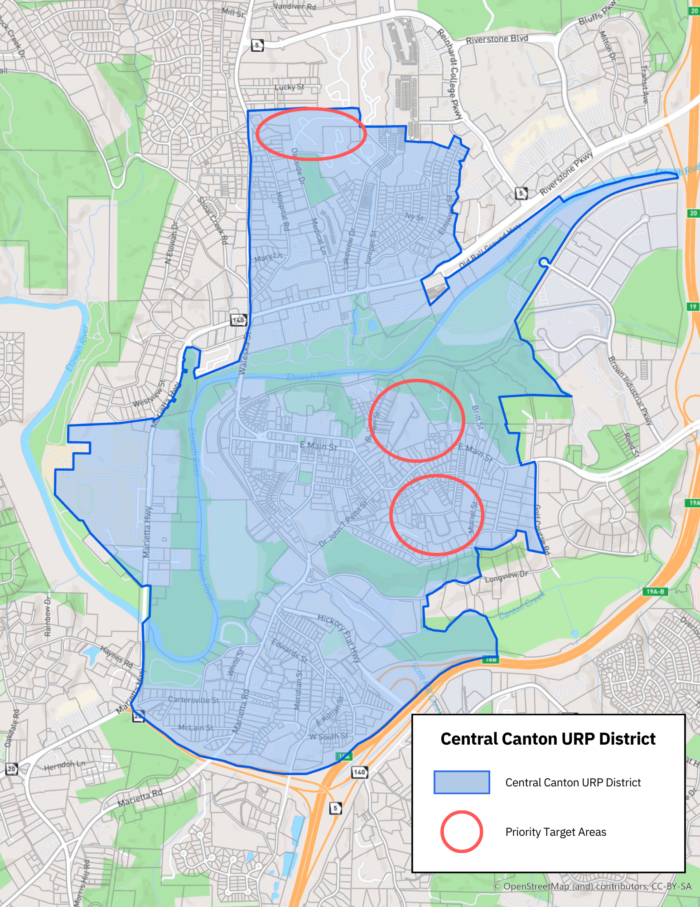

2023 HUD QCT and Census Tracts

Negative Conditions within the Redevelopment Area

The Central Canton Urban Redevelopment Area contains a mix of older retail, office, residential, and light industrial land uses within Canton’s historic central town area. Like most redevelopment areas, many of the properties are blighted. Significant disinvestment, decay and obsolescence characterize the commercial, residential, and light industrial corridors in the area.

The Georgia Urban Redevelopment Law (O.C.G.A. 36-61-1 et. seq.) defines a redevelopment area as a “slum area which the local governing body designates as appropriate for an urban redevelopment project.”

A "slum area” is defined by the Act as having:

- The presence of a substantial number of slum, deteriorated, or deteriorating structures;
- Predominance of defective or inadequate street layout;
- Faulty lot layout in relation to size, adequacy, accessibility, or usefulness;
- Unsanitary or unsafe conditions;
- Deterioration of site or other improvements;
- Tax or special assessment delinquency exceeding the fair value of the land;
- The existence of conditions which endanger life or property by fire or other causes;
- Having development impaired by airport or transportation noise or by other environmental hazards;
- Any combination of such factors,
- Substantially impairs or arrests the sound growth of a Governmental Entity, retards the provisions of housing accommodations, or constitutes an economic or social liability and is a menace to the public health, safety, morals, or welfare in its present condition and use.
The following negative conditions are found within the urban redevelopment area. Each of the negative conditions are either affects or indicators of the slum area description included in Georgia’s Urban Redevelopment Law.

Pervasive Poverty

Compared with Cherokee County and the City of Canton, the population of Census Tracts
904.01, 906.04 and 906.05 reflect many of the characteristics of poverty. Overall, the median household income and per capita income is significantly lower than the comparison areas.

Comparison Statistics  Census Tract | 904.01 | 906.04 | 906.05 | Cherokee County | Canton
Population | 5,635 | 3,069 | 3,995 | 274,615 | 34,576
Median Age | 27.7 | 34.5 | 33.3 | 39 | 34.4
Per Capita Income | $21,997.00 | $29,592.00 | $24,255.00 | $40,675.00 | $30,342.00
Median Household Income | $42,898.00 | $60,659.00 | $63,164.00 | $90,681.00 | $67,355.00
Persons Below Poverty Level | 27% | 28.70% | 16.20% | 7.00% | 15.10%
Number of Households | 2,564 | 1,073 | 1,159 | 94,208 | 11,475
Source:
American Community Survey 2021

Underdevelopment
There is significant underdevelopment in the Central Canton Area. Despite the approved zoning which permits a broad range of permitted uses and its place as the local business and cultural center, development in the area has been sporadic resulting in slow and minimal growth. Central Canton remains underserved by employment opportunities, shopping and recreational options, and desirable housing.

Central Canton qualifies as a redevelopment area under the Redevelopment Powers Law and the Urban Redevelopment Act because of several factors including, without limitation, the following:

Structural Age and Deterioration
The vast majority of the buildings in the historic downtown portion of the Central Canton Urban Redevelopment Area were constructed between 1892 and 1930 and have changed uses multiple times. Consequently, they are out of date and have become somewhat dilapidated because of the passage of time and frequent use. In the case of many vacant sites, absentee landlords maintain ownership with minimal to no improvements to their buildings. Residential Structures within the Central Canton Urban Redevelopment Area were built in the early 1900s up to the 1950s and 1960s in the edge portion of the Redevelopment Area.

Inefficient and Obsolete Commercial Design and Layout
The existing commercial vacancies and freestanding structures are inefficient with respect to site use and density. Most are considered unattractive with respect to current standards and obsolete with respect to consumer market appeal. Store frontage and signage are below current market standards and design.

Lack of Retail Market Appeal
Many of the retail operations in the Central Canton Urban Redevelopment area are small businesses that are locally owned and operated. Consequently, these smaller businesses do not have the brand recognition, product offerings, marketing capacity, pricing, merchandising or basic critical mass to appeal to the increasingly affluent potential customer within either the primary or secondary retail markets. As development and redevelopment in the Central Canton Urban Redevelopment area progresses, the area will be able to accommodate a denser concentration of commercial and light industrial operations that will be of significant benefit to Canton and Cherokee County. Furthermore, development and redevelopment will encourage the patronage of individuals and entities located throughout the north metropolitan Atlanta region.

Economic Underutilization of Developable Land
A significant proportion of developable land within the area is underutilized with respect to potential density, type of development and/or resulting market and taxable values. Many parcels suitable for commercial development are currently vacant or poorly maintained.

Underachievement as Employment Center
Current employment opportunities are limited in the Central Canton Urban Redevelopment area. Professional service opportunities abound; however, they do not give way for desirable retail, dining, and entertainment opportunities also suitable for the corridor. Revitalizing the area as an employment center could enhance County and City tax bases, create new jobs, and provide convenient shopping opportunities for local residents. Retail and service industry employment is constrained by the lack of competitive retail offerings and amenities such as restaurants and convenience stores. A customer base for cafés, restaurants, and retail uses located in the area is crucial to its success as an employment center.

Lack of Rental Revenue Generation
When properties become vacant, they typically sit available for many months and most of the time, years. Absentee landlords make little to no improvements to their properties resulting in deterioration, blight, and a loss of a host of revenues.

According to research conducted by Donovan D. Rypkema of Place Economics, a vacant commercial building could have a negative economic impact of $386,750 annually. This result is a combination of lost sales dollars, lost property management fees, lost property tax revenues to local government, lost sales tax revenues to state and local governments, lost rents to property owners, lost loan demand to local banks for the business, lost employee payroll, lost business profits and owner compensation, and lost loan demand to local banks for the building.

General Distress
Some parcels within the Central Canton Urban Redevelopment area are suffering from considerable distress and disinvestment.

Crime
The Central Canton Urban Redevelopment area is the social and business center in the city of Canton. The residential areas of Sunnyside have a low volume of reports. Most of our reports
from this area are traffic related on the main corridor of Marietta Rd. There is the occasional report from the Canton Village area regarding a (usually alcohol induced) fight or argument near La Oaxaquena, though they do not occur often enough to take note. Regarding the “priority target areas” of Crisler St, Shipp St, and Oakside, there is moderate drug activity in these areas. Reports of anything violent are few and far between and usually stretch no further than domestic disputes.

City of Canton Crime Statistics

 | YTD 21 | YTD 22 | YTD %
TOTAL CALLS FOR SERVICE | 28,840 | 25,377 | -12%
VIOLENT CRIMES | YTD 21 | YTD 22 | YTD %
HOMICIDE | 1 | 3 | 200%
RAPE | 9 | 25 | 178%
ARMED ROBBERY:
GUN | 3 | 4 | 33%
KNIFE | 0 | 0 | 0%
OTHER DANGEROUS WEAPONS / STRONG-ARM | 1 | 1 | 0%
AGGRAVATED ASSAULT:
FIREARM | 31 | 14 | -55%
KNIFE/CUTTING INSTRUMENTS | 3 | 7 | 133%
OTHER DANGEROUS WEAPONS | 0 | 2 | 200%
HANDS, FIST, FEET, ETC AGG. INJURY | 11 | 16 | 45%
TOTAL VIOLENT CRIMES | 59 | 72 | 22%
PROPERTY CRIMES | YTD 21 | YTD 22 | YTD %
BURGLARY:
FORCED | 10 | 10 | 0%
NON-FORCED | 1 | 9 | 800%
THEFT:
LARCENY | 175 | 195 | 11%
SHOPLIFTING (Larceny) | 183 | 120 | -34%
MOTOR VEHICLE THEFT | 25 | 28 | 12%
TOTAL PROPERTY CRIMES | 394 | 362 | -8%
TOTAL PART 1 CRIMES | 453 | 434 | -4%
OTHER OFFENSES
OTHER ASSAULTS-SIMPLE | 234 | 141 | -40%
TOTAL ARRESTS | 1251 | 935 | -25%
DUI ARRESTS | 127 | 90 | -29%
TRAFFIC ACCIDENTS | 1638 | 1632 | 0%
TRAFFIC CITATIONS | 4,312 | 2,357 | -45%
TOTAL WARNINGS | 1,237 | 973 | -21%
OTHER CITATIONS | 185 | 105 | -43%
TOTAL CONTACTS | 5,734 | 3,435 | -40%

Property Maintenance and Code Compliance
The economic downturn and credit crunch in financial markets led to a marked increase in property maintenance and code compliance issues with both residential and commercial properties. This problem is the result of a series of different behaviors by property owners depending on their financial situation.

Property owners in financial trouble are not able to focus on maintaining their property because they are more concerned with providing basic necessities. Financially-stable property owners watched their property values drop significantly therefore they are hesitant to invest any additional money into their property for fear they will continue to lose value. Those properties that have gone through foreclosure are now owned by banks and are not properly maintained.

Once a home or a business becomes vacant, it is more likely to be the focus of vandals or other crimes. The costs of getting vacant buildings up to fire and building code compliance plus exterior finishing costs may also deter private investment and building occupancy.

Properties with Environmental Concerns
A number of the properties in the Central Canton Urban Redevelopment Area have a history of land uses that cause environmental concerns. This is true for properties that have been in use for industrial businesses, gas stations, auto/machinery repair and inert landfills prior to environmental regulations. Prior to the 1960’s, these land uses were largely unregulated and likely to have areas of soil or groundwater contamination.

While the real extent of the problem may not be known, the potential for environmental issues is often enough to cause real estate deals to fall apart prior to starting the environmental assessment process. These potential brownfields can affect property values of surrounding parcels because of the uncertainty about contamination and cleanup costs.

Blight
The Central Canton area contains a considerable number of properties and infrastructure that exhibit signs of blight i.e. deterioration sufficient to constitute a threat to health, safety and public welfare. Below are examples of blighted properties in the area.
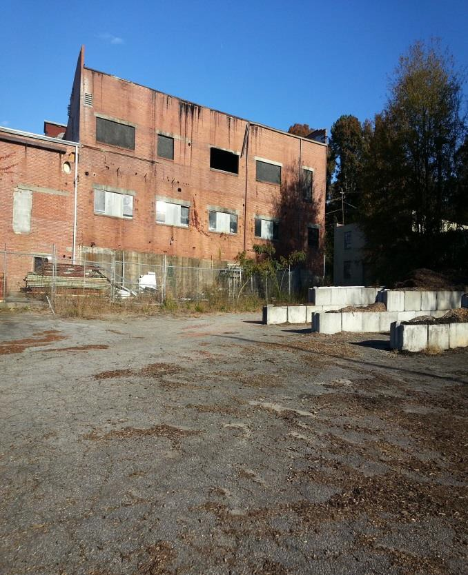
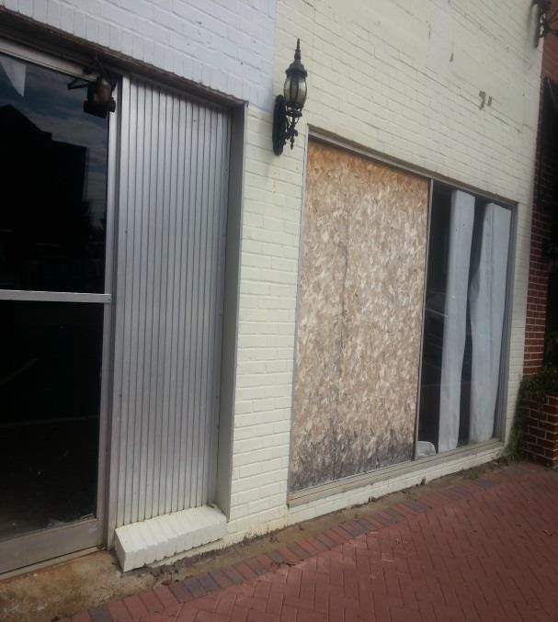

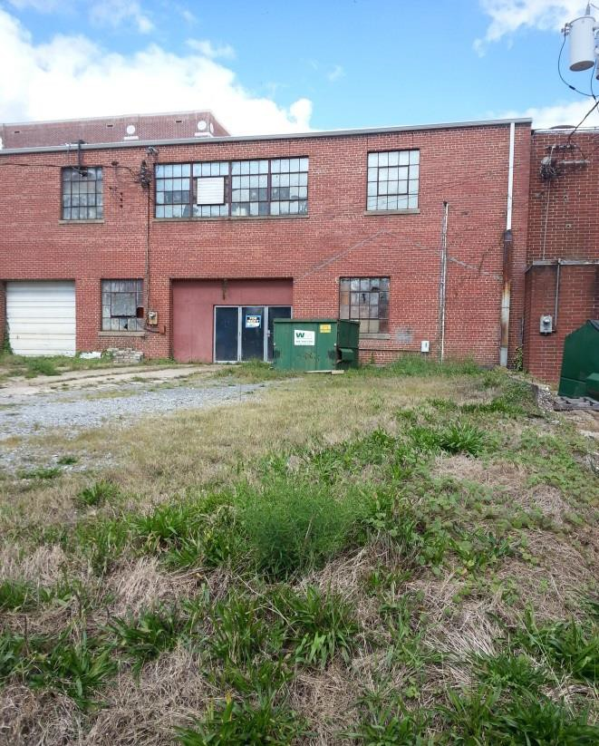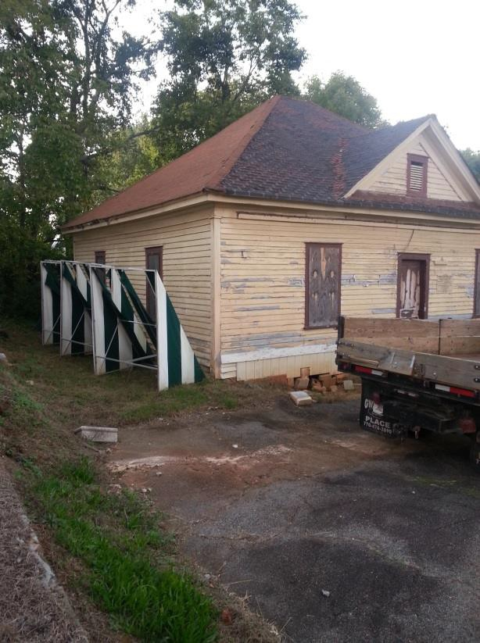

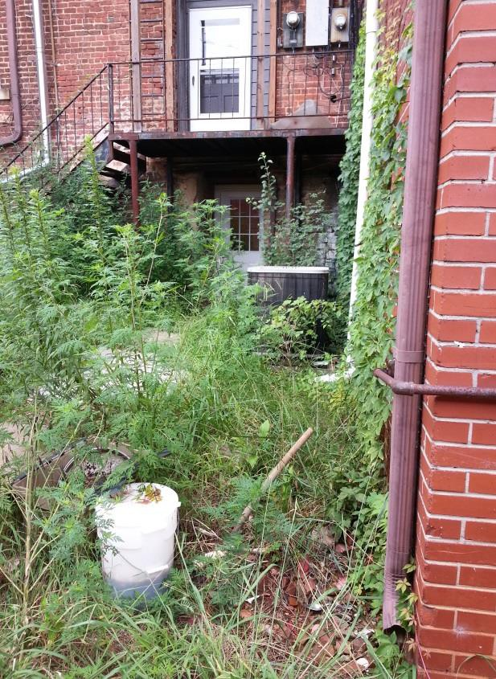
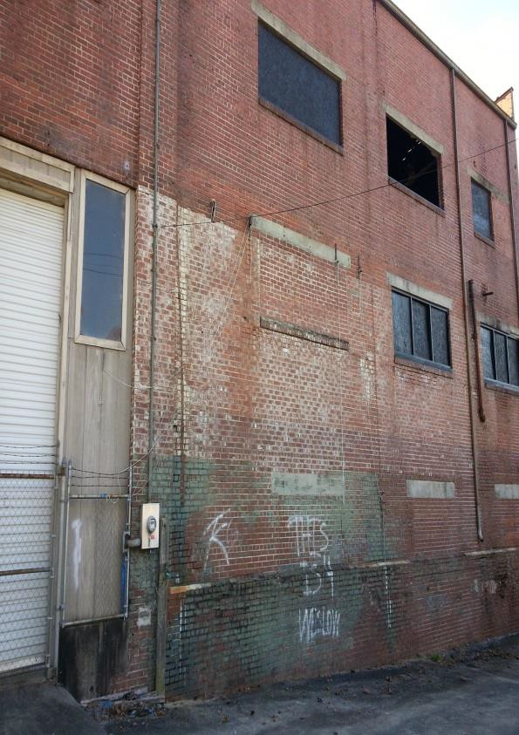

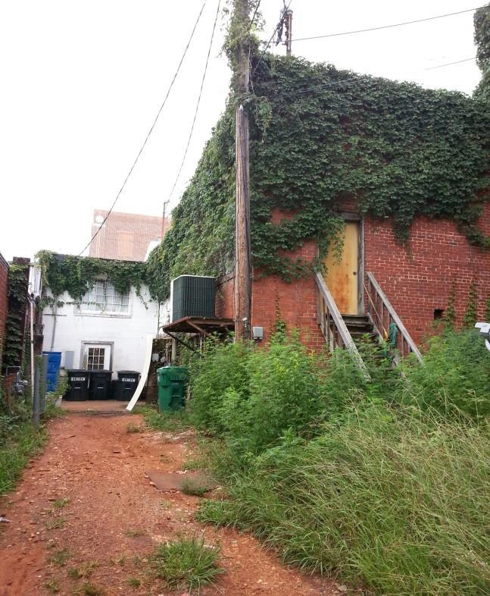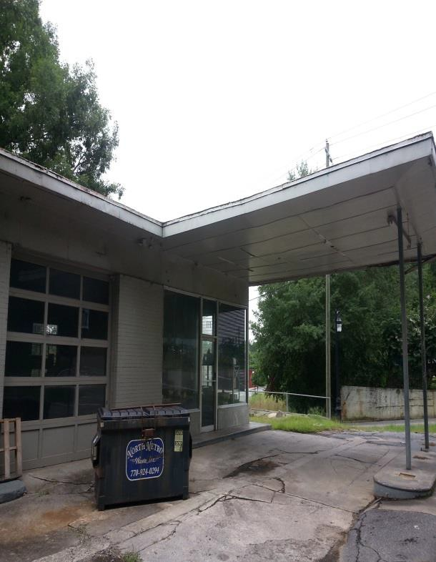
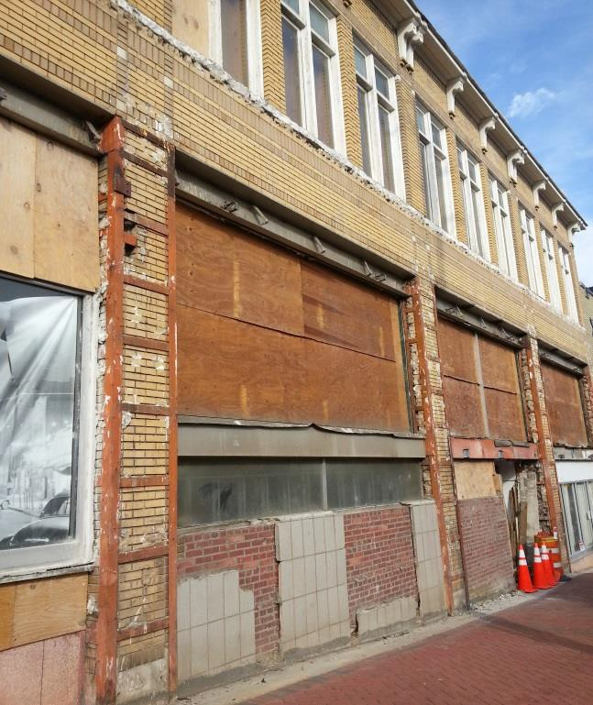
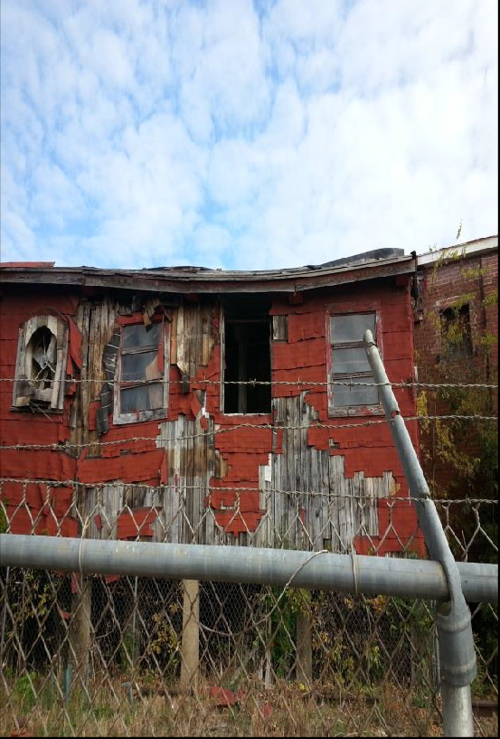

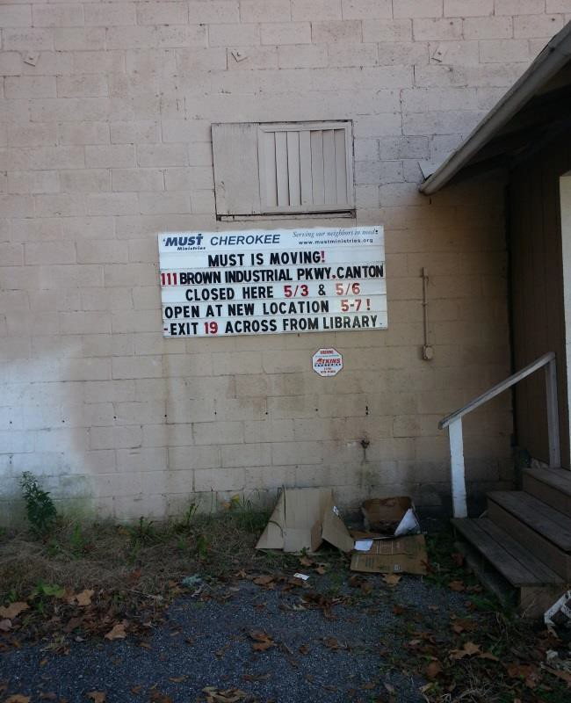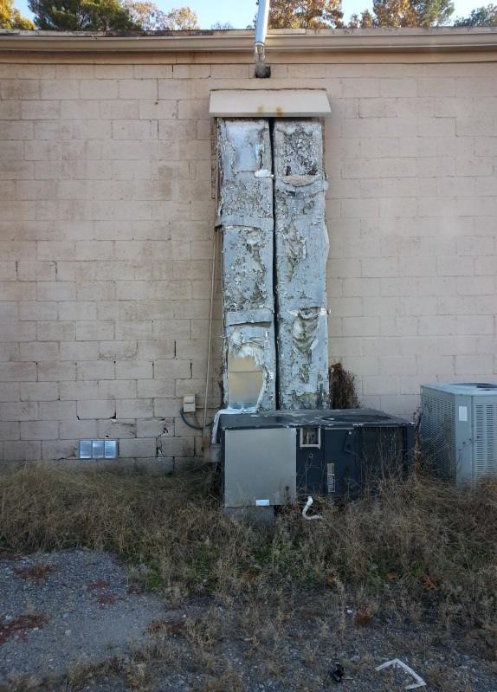
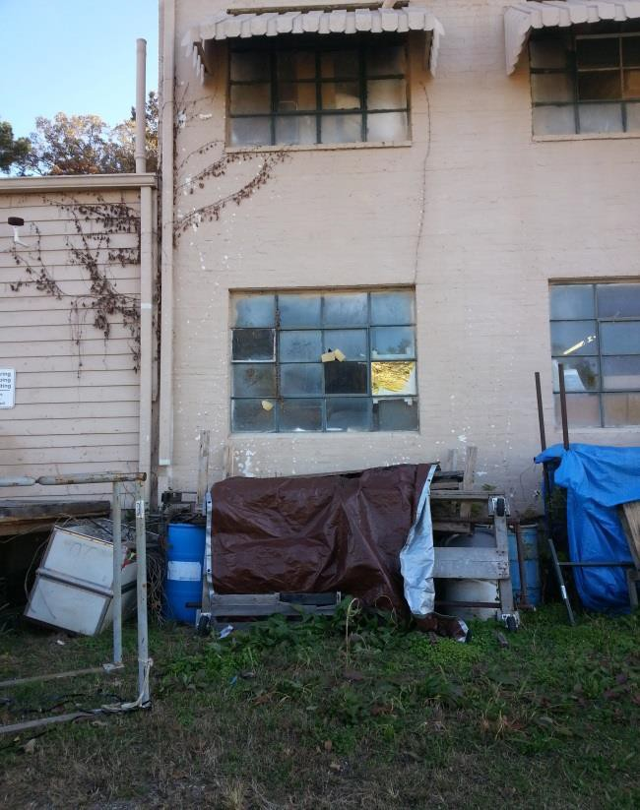
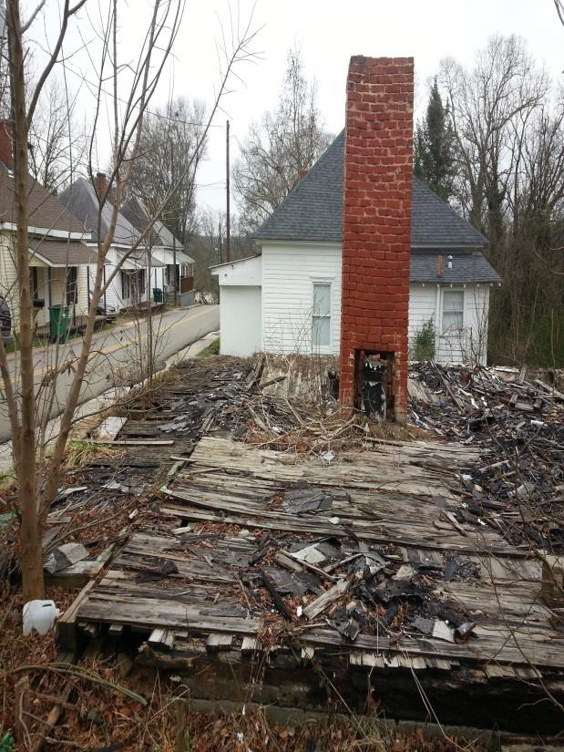

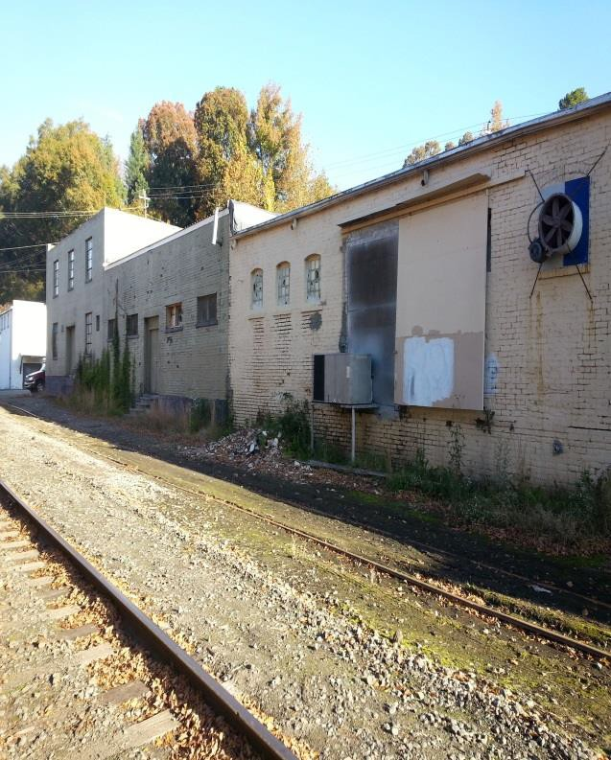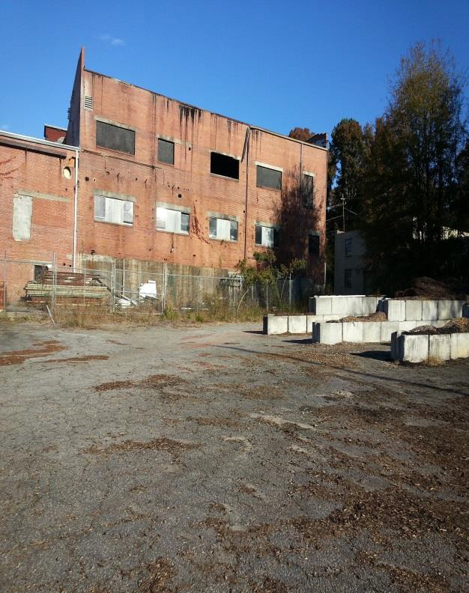
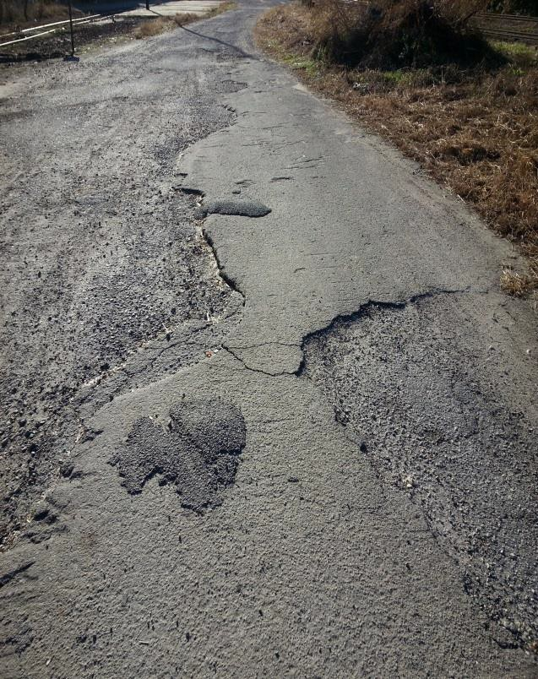
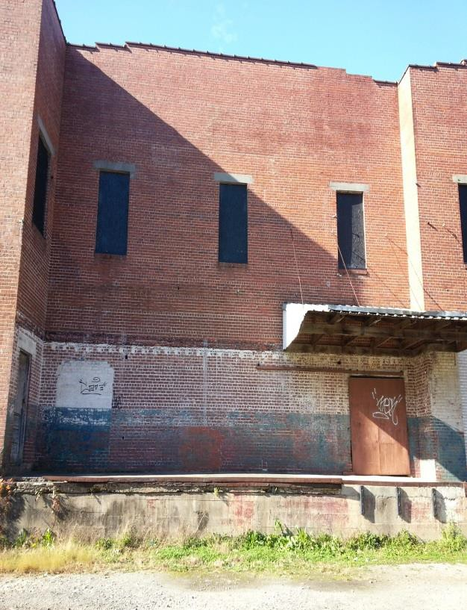

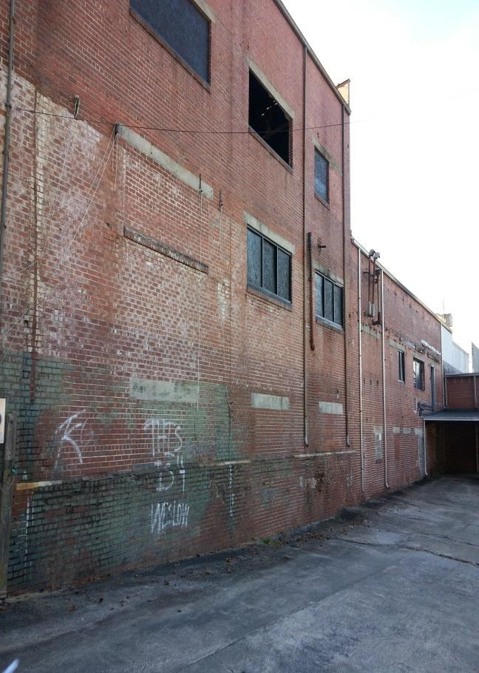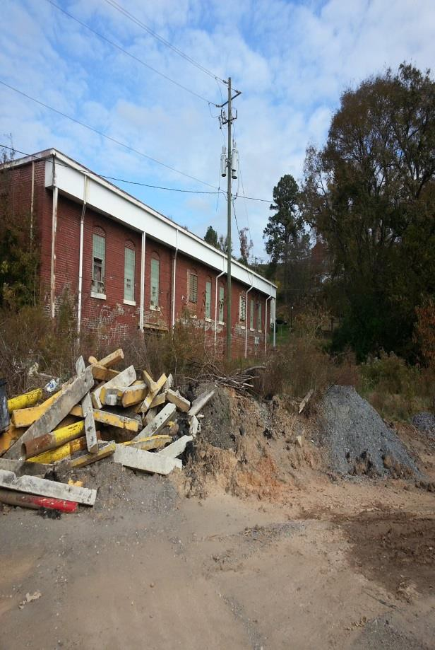
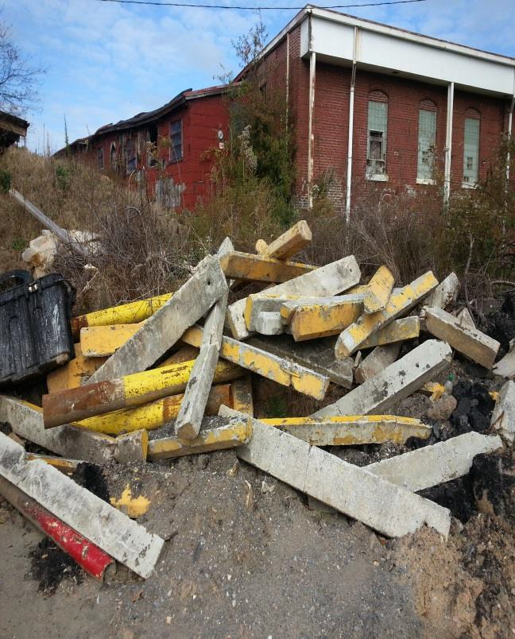
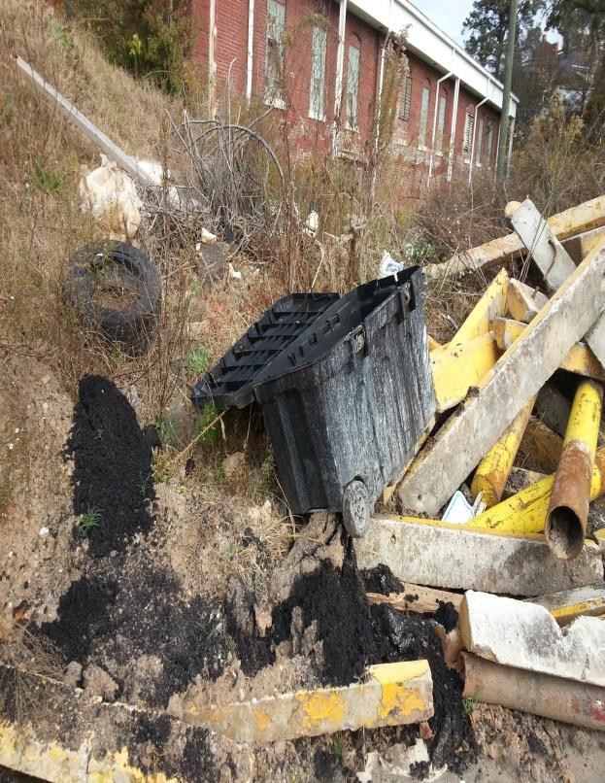

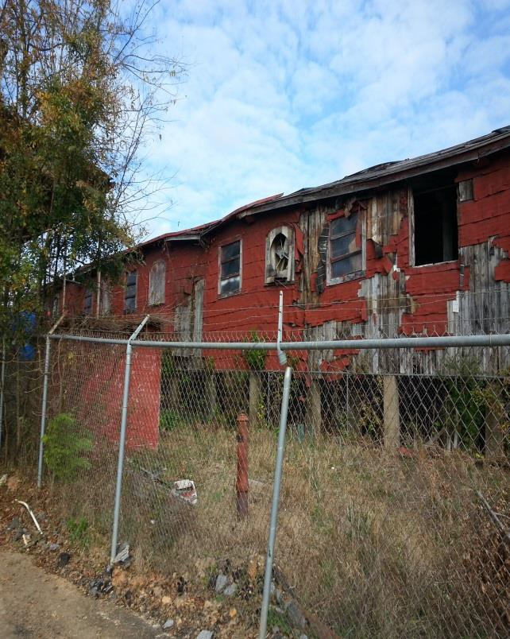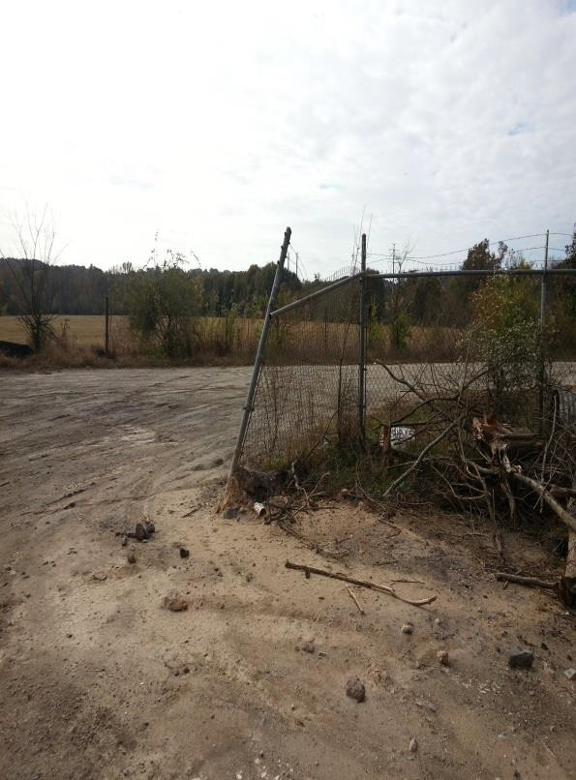

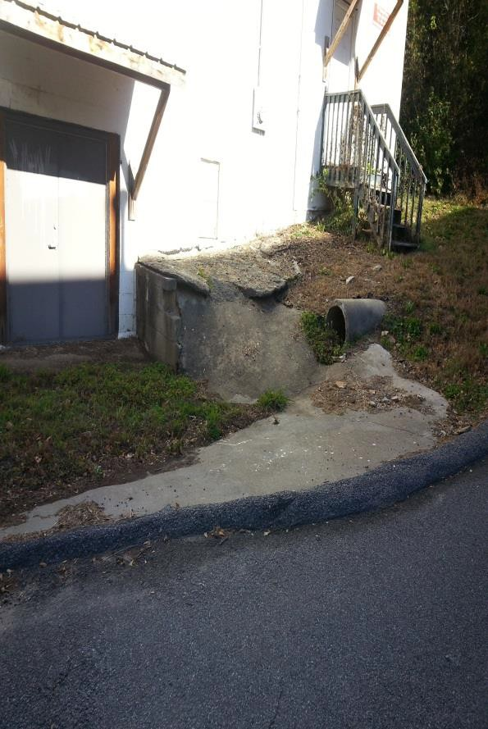
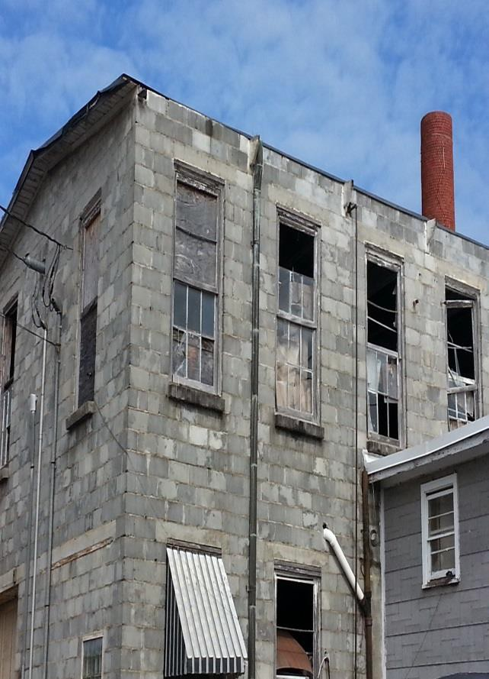

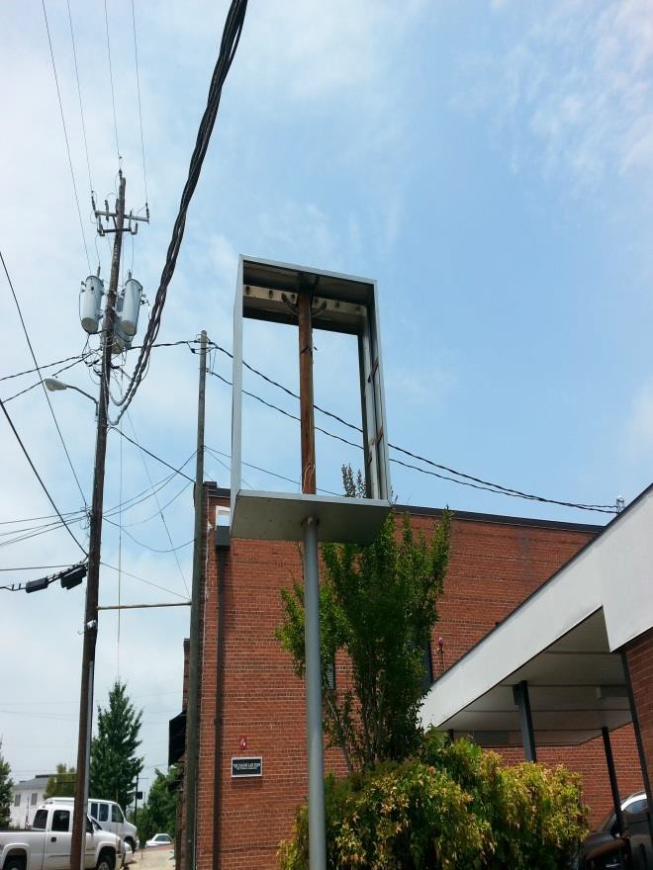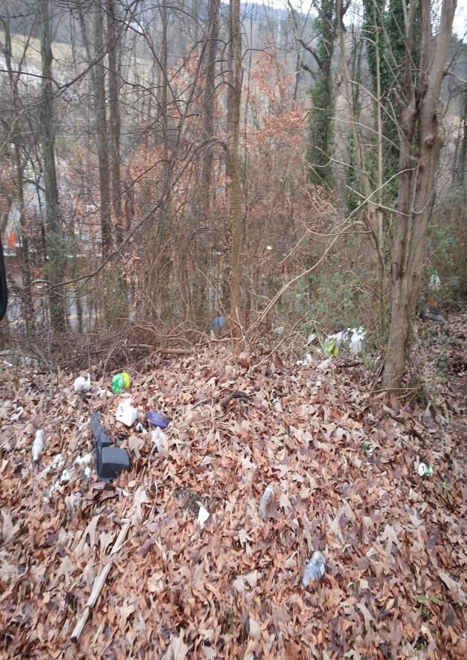
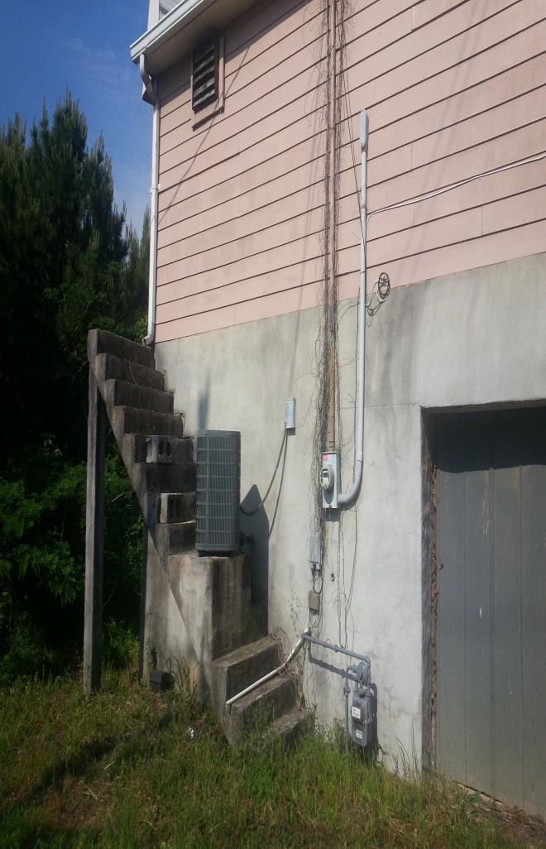
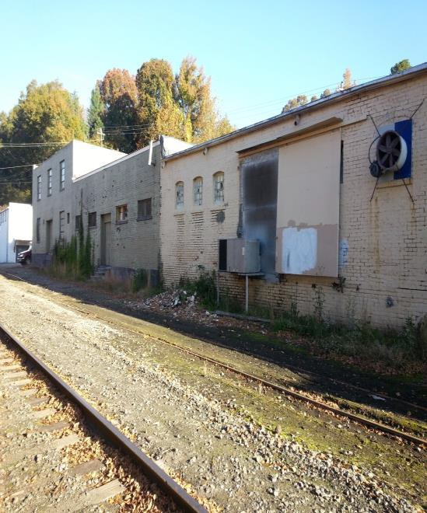

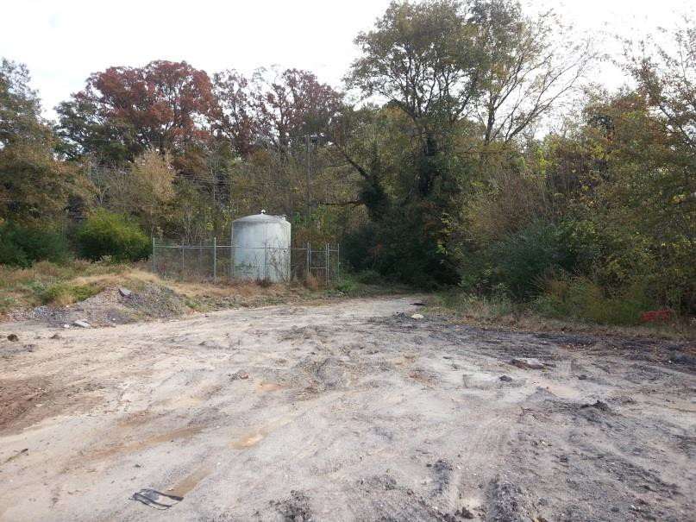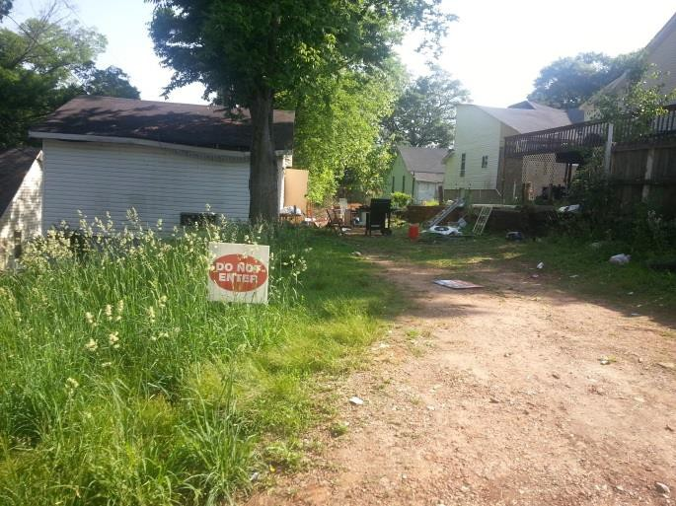
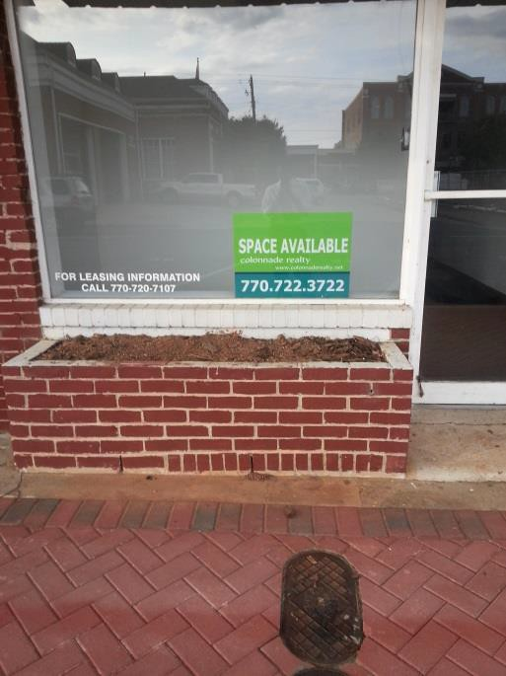
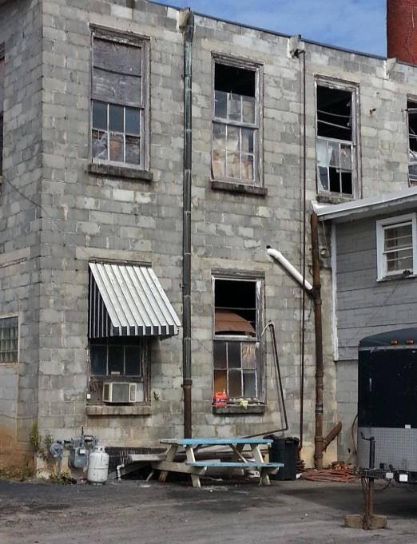

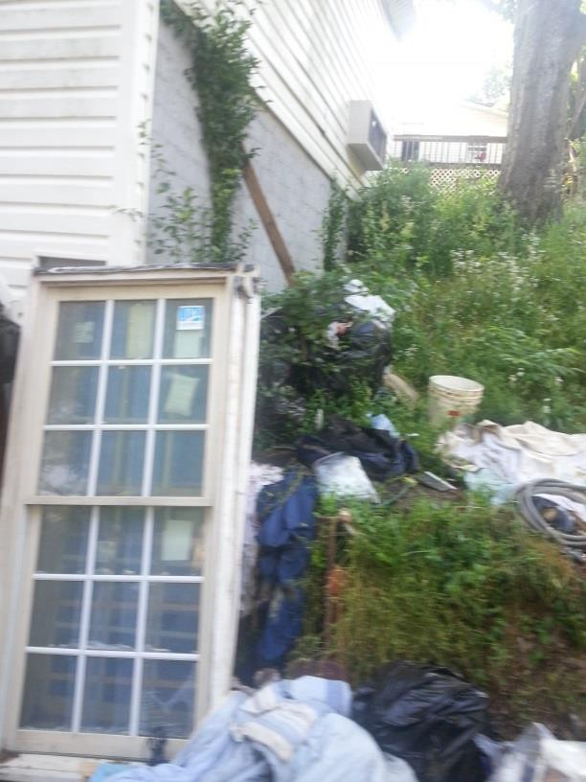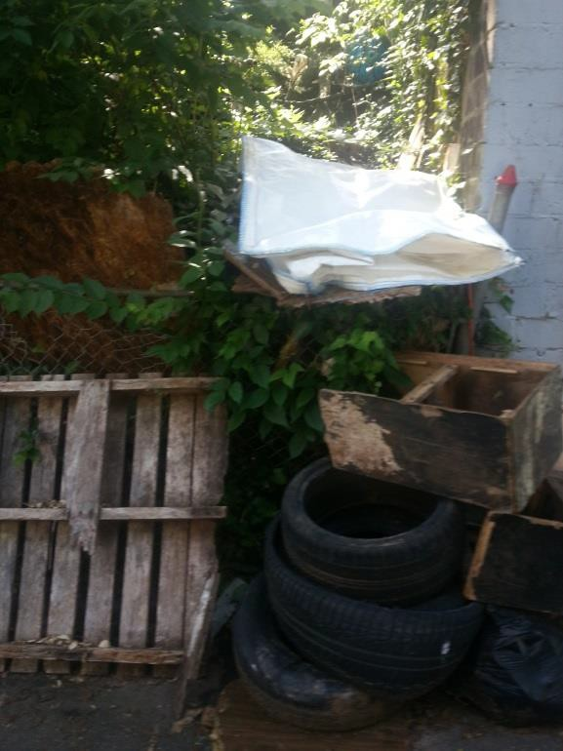

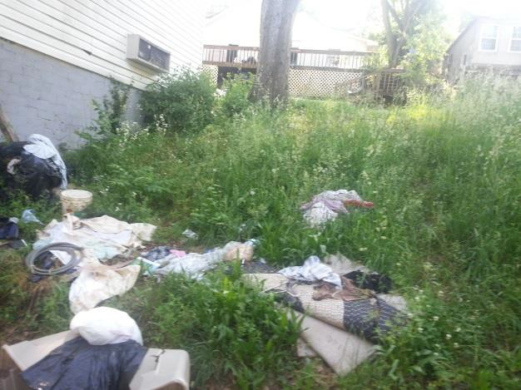
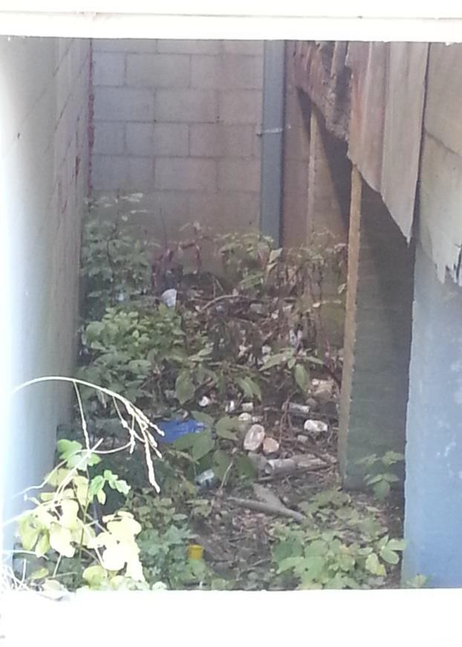

Economic Outlook

The outlook for Central Canton is strong because of the tremendous development potential as an employment center with nearby workforce housing options and significant public investment.

Development Potential
The Central Canton Urban Redevelopment Area is filled with sites that are either primarily undeveloped or ripe for redevelopment.
Surrounding Workforce Housing
The existing residential neighborhoods offer a full range of workforce housing, from affordable apartments to modest townhomes to detached single-family homes. Some of the apartment complexes inside the Central Canton Urban Redevelopment Area were built with Low Income Housing Tax Credits (LIHTC) so they contain units that are limited to individuals with incomes below 80% of the Area Median Income (AMI). The range of options in single-family detached housing is varied in the area around and within Central Canton. There are homes built from the late 1800’s as well as brand new homes. The variety of housing options in the Central Canton Urban Redevelopment Area is a strong asset for attracting employers and commercial development. Additionally, many of the older mill houses are in a deteriorating state. Because they are clustered in desirable, high-activity location, they carry significant redevelopment potential.

Leveraging Public Investment
Recognizing the problems in the Central Canton Urban Redevelopment area, city leaders have worked for over a decade to make investments in capital projects and infrastructure to address critical needs. This Urban Redevelopment Plan aims to leverage these projects to bring private economic development investment to this part of the City of Canton.

City of Canton Roadmap for Success
The City’s Roadmap for success provides a guide of goals, objectives, and actions to completing the Roadmap for Success.

Capital Investments

Agency | Project | Est Cost | Est Completion
*City of Canton | Traffic Signal Reservoir Drive/Hickory Log Drive | $1 million | Completed March 2023
*GDOT/City of Canton | Traffic Signal Reservoir Drive/Reinhardt College Pkwy | $1.5 million | In Design – Construction scheduled to begin Fall 2023  Const complete Spring 2024
*GDOT/City of Canton | Intersection Improvement Reinhardt College Pkwy/Waleska Road | $3 million | In Design – Scheduled to begin Fall 2026  Const compete Winter 2027
*GDOT/City of Canton | Intersection Improvement Waleska Rd/Marietta Hwy | $3.2 million | In Design – scheduled to begin Spring 2026  Const complete Fall 2027
*GDOT/City of Canton | Pedestrian Improvement Medical Drive/Riverstone Pkwy | $100,000 | In Design – Scheduled to begin Fall 2023  Const complete Winter 2023
City of Canton | Downtown Parking Deck with Solar and EV Charging | $3.5 million | Completed March 2023
City of Canton | Harmon Park Improvements | $4.7 million | In construction – scheduled completion Summer 2023
City of Canton | Downtown Master Plan | $170,000 | Scheduled to begin May 2023 – complete May 2024
City of Canton | Canton Transportation Master Plan | $100,000 | Complete January 2023
City of Canton | West Main Street Ped Corridor and Utility Relocation | $1.5 million | In Design – Construction scheduled to begin Fall 2023  Complete Early 2025
Appalachian Regional Commission/City of Canton | The Mill Pedestrian Bridge over the Etowah River | $2 million | Federal Grant received – Design to begin Summer 2023  Construction Complete Summer 2025

- Project is within 1 mile of Oakside Priority Target Area

CONSISTENCY WITH ADOPTED PLANS
To ensure that the Downtown Canton Urban Redevelopment Plan maintains compatibility with the City of Canton Comprehensive Plan, components of the City’s Comprehensive Plan’s Community Agenda were used to guide the development of the Urban Redevelopment Plan. Of specific interest include the Community Vision, Future Development Strategies, and the Implementation Goals.

The vision for the Central Canton Urban Redevelopment area is reflected in the City of Canton’s Comprehensive Plan. Components of the Comprehensive Plan’s Community Agenda were used to guide the development of the Central Canton Urban Redevelopment Plan. In addition, the City has also worked to establish other incentives and land use regulations such as the River Mill Livable Centers Initiative Enterprise Zone and the Canton Overlay Zone Community Standards Ordinance.

City of Canton Comprehensive Plan

The Canton City Council adopted Canton 2040 on March 21, 2019. Canton 2040 sets the table for the implementation of Canton’s vision for the future of the City. The Comprehensive Plan provides the policy guidance for future development in and around the City of Canton. The City of Canton identified issues and opportunities relating to a variety of measures including economic development, natural and cultural resources, facilities and services, housing, land use, traffic and transportation, and intergovernmental coordination.

Comprehensive Plan Vision

The Community Vision provides a general framework for the Comprehensive Plan. The following concepts from the Community Agenda shape this plan:

- Maintain the character of the community
- Provide affordable housing and a balanced land use mix
- Create economic development opportunities
- Protect environmental and historical resources
- Expand and enhance community facilities and services
- Improve the City’s transportation network for automobiles and pedestrians alike
- Ensure that future development patterns and infrastructure are fiscally sustainable

Description of Character Areas and the Development Strategy for Each

According to the Comprehensive Plan, future development within the City of Canton is projected to occur within nine unique character areas. A description of these character areas is below, along with the respective development strategy for each.

Natural Areas
- Undeveloped, natural lands with significant natural features including floodplains, wetlands, watersheds, wildlife management areas and other environmentally sensitive areas not suitable for development of any kind.
  - Development Strategy: No new development will be allowed within natural areas in order to retain the land’s natural state. Conservation easements and covenants will be promoted within these areas along with opportunities for recreation.

Natural areas should act as an amenity to local residents and visitors. New development will only occur in suitable locations to avoid and protect any existing natural resources, utilizing low impact development techniques to preserve the natural topography and existing greenery of a site.
Employment Centers
- Light industrial and mixed office and smaller commercial uses, or campus environments that accommodate employment. They provide light industrial uses in low intensity manufacturing, wholesale trade, and distribution activities that do not generate excessive noise, particulate matter, vibration, smoke, dust, gas, fumes, odors, radiation, or other nuisance characteristics.
  - Development Strategy: Improve the quality of employment areas by enforcing guidelines for signage, lighting, site development, and landscaping within the area. Traffic mitigation and landscaping buffers will be used to separate more intense uses from incompatible adjacent uses and minimize the negative impacts. Finally, the City intends to reduce the auto dependency of workers within employment centers by mixing uses and improving walkability.
Downtown/Urban Centers
- Located in the heart of Canton, this area includes the greatest mixture of diverse land uses than any other character area. In Canton’s downtown core, commercial and local government buildings dominate the area. Industrial land sits to the West of this area.
  - Development Strategy: The downtown area should include a diverse mix of uses that will attract activity during all hours of the day, including evenings and weekends. Pedestrian accessibility will accommodate a broad range of visitors and their mobility preferences. On street parking, parking lots behind buildings and improved landscaping will improve the pedestrian friendly atmosphere of the area and connect it to the adjacent neighborhoods. Finally, the City will promote infill development to increase density and promote activity in a compact, urban center while maintaining the small-town feel of Canton’s downtown.

Community Level Mixed Use / Retail Centers
- Predominantly retail/office commercial land uses combined with some multi-family residential and institutional uses to accommodate the neighborhood population. This area provides the site for major auto-oriented retail centers and similar commercial facilities; it is heavily vested in automobile access. Some higher density residential facilities are located nearby and may present opportunities for providing uses that are more diverse in the future.
  - Development Strategy: Attract more local activities outside normal business hours and include a greater diversity of uses and public facilities to serve a wider market area. The focus should be on adding residential density, mixing uses, and regulating the design of big-box shopping centers. Transportation and way finding systems should be improved to accommodate vehicular and non-vehicular travel.
Major Highway Corridor / In-Town Corridor
- Primarily auto-oriented and experience high traffic volumes, making them well-suited for relatively larger-scale commercial uses (such as strip development) compared to the downtown core. These auto-oriented uses rely on capturing the high volumes of traffic passing by, and they typically include large parking lots and setbacks in order to accommodate this traffic.
  - Development Strategy: The City will develop strict guidelines for signage, building design, lighting, site development, and landscaping standards in order to ensure quality development along the corridors in this character area. Additionally, connectivity and transportation will be improved among the surrounding neighborhoods by increasing access points and improving non-vehicular transportation infrastructure. Transportation improvements include clear signage, slowing traffic speeds, and improving safety through landscaping and streetscape design.
Historic Area / Traditional Neighborhood Stable
- Demonstrate a well-established and maintained stock of housing, a sense of neighborhood identity which may be drawn from architectural style or lot and street design. It is generally a stable area of neighborhoods near employment centers.
  - Development Strategy: Within this area, the city will protect historic structures and promote renovation of any properties which begin to show signs of decline using tax incentives from properties on the National Historic Register. Any infill development will blend into the neighborhood in terms of scale and design and maintain the historic character of the area. Additionally, the creation of parks and pedestrian infrastructure will encourage mobility throughout the area and allow residents to enjoy and gain an appreciation for the area. Promoting home ownership and maintenance of historic properties will help stabilize the neighborhood and a neighborhood center in order to provide local residents with a place to shop, enjoy entertainment, and gather.
Neighborhood Living
- Neighborhoods which are somewhat denser than rural housing but less dense than the areas directly surrounding the urban core. Residences in the Neighborhood Living character areas are likely to be in relatively good repair and have a somewhat continuous architectural style throughout each neighborhood.
  - Development Strategy: Redevelopment will be permitted to increase density, particularly around transit stops and retail centers. New types of development will also be encouraged in this area to promote and attractive and livable community. Compatible land uses include medium density residential, senior housing, institutional uses, and parks/green space.
Suburban Area Developing
- These areas are located along the edges of the City of Canton. The contain low-density residential developments with no connections to transit. Pedestrian accessibility and other street amenities are dependent on project requirements specified in the planning, zoning and permitting process. Many of these areas have steep topography, making building a challenge and threatening some of the scenic vistas which are a great asset to the city.
  - Development Strategy: To improve connectivity and transportation options in these areas, traditional neighborhood development strategies will be encouraged to promote smaller lot sizes, interconnected streets, and pedestrian infrastructure. Traffic calming measures will be implemented to slow automobile traffic and encourage non-vehicular traffic. Increasing the acreage of greenspace and recreational facilities and connecting these areas to each other through a network of trails and sidewalks will increase livability for the residents. Finally, the addition of neighborhood level commercial development will better serve the needs of the local population.
Traditional Neighborhood Redevelopment Area
- Contains moderate density with older houses and community facilities that may be in need of revitalization. These areas are designated as Traditional Neighborhood Redevelopment Areas, and represent older neighborhoods with a significant stock of older, somewhat dilapidated homes and other structures that have declined due to lack of investment. Some of the building stock is in poor condition, and there may be large areas of vacant land or deteriorating, unoccupied structures.
  - Development Strategy: Incentives will be provided to preserve and rehabilitate recoverable structures in order to create an attractive neighborhood with a blend of historic and new housing. The City will apply traditional neighborhood development principles to improve connectivity and walkability. Increasing the acreage of greenspace and recreational facilities and connecting these areas to each other through a network of trails and sidewalks will increase livability for the residents. Finally, the addition of neighborhood level commercial development will better serve the needs of the local population.

City of Canton Overlay Zone Community Standards Ordinance

The City of Canton Overlay Zone Community Standards Ordinance includes information which establishes specific standards and regulations governing the landscape and signage of all development within established corridors and intersections. The City of Canton understands the connections between land use and transportation facilities. These Overlay Standards strive to balance land use acceptability with transportation accessibility, mobility, utility, and costs within the context of good design and engineering practices.

Technology Ridge Opportunity Zone

Approved in 2012, the Technology Ridge Opportunity Zone is a joint project of Cherokee County and the cities of Canton and Ball Ground. The Technology Ridge Opportunity Zone consists of 3,772 acres and is the first multi-jurisdictional Opportunity Zone in Georgia. The zone includes the area west and south of Interstate 575 at the interchange with Riverstone Parkway along Old Ga. 5; the area east of I-575 along Old Ga. 5 north to Ball Ground; and the western side of I-575 around the Howell Bridge Road.
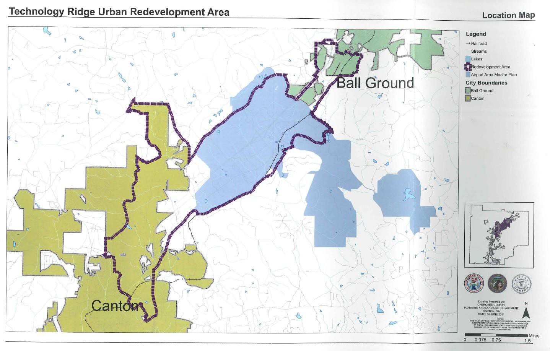

River Mill Livable Centers Initiative Enterprise Zone

Approved in 2003, the River Mill Livable Centers Initiative Enterprise Zone is immediately adjacent to downtown Canton. It strategically overlaps with portions of the Central Canton Urban Redevelopment Area. Businesses located in the enterprise zone become eligible to receive property tax abatements if they hire five or more full-time employees and provide additional economic stimulus to the area. The River Mill Livable Centers Initiative Enterprise Zone was established as Appendix F of the City of Canton’s Zoning Ordinance.

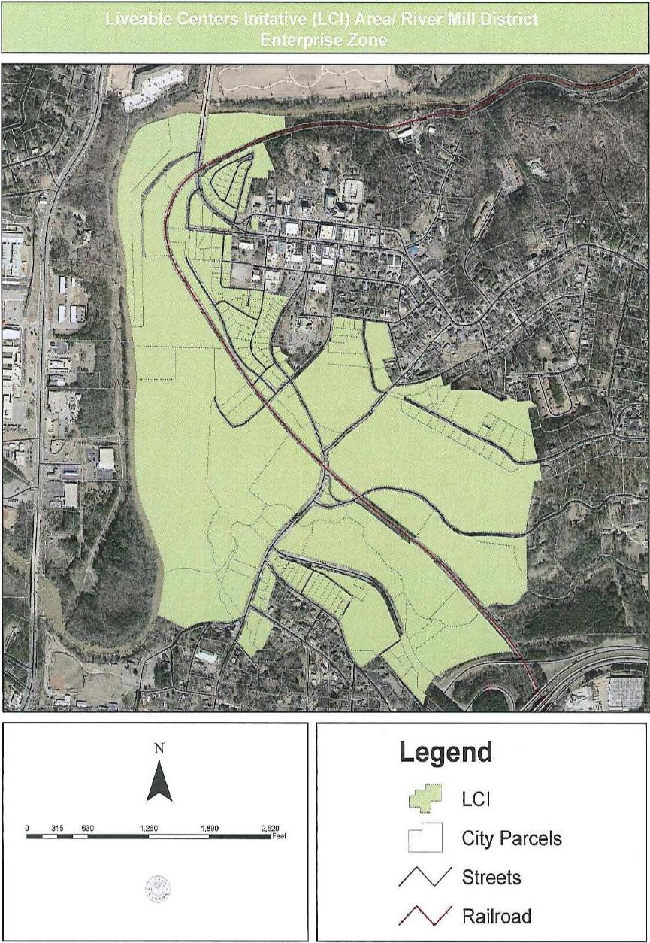

GOALS AND STRATEGIES FOR CENTRAL CANTON

Policies recommended in the Urban Redevelopment Plan will complement the development strategies of each unique Character Area. Additionally, the planning and implementation goals of this Urban Redevelopment Plan are consistent with the overall goals, policies, and objectives of the City of Canton Canton 2040 Comprehensive Plan. Specifically, the following Comprehensive Plan goals and policies were used to guide the vision of this Urban Redevelopment Plan:

Economic Development
The City of Canton Urban Redevelopment Plan will support a growing and balanced economy that bolsters the community’s position as a regional economic engine offering high-wage jobs, by ensuring a high-level of workforce adequacy.

Policies:
- Our new and reconstructed roadways will be appropriately designed and use context sensitive design considerations to enhance community aesthetics and to minimize environmental impacts.
- Carefully consider costs and benefits in making decisions on proposed economic development projects.
- Consider the employment needs and skill levels of our existing population in making decisions on proposed economic development projects.
- Encourage businesses, schools, and other institutions to include bicycle parking and traffic management in their development projects.
- Encourage creation of a community-wide network of roads, railroads, walking paths, bicycle trails, car-pooling, and other alternative transportation choices and facilities to meet multiple functions for roads and transport facilities, including pedestrian facilities, parking, bicycle routes, public transit (bus and/or rail), and local vehicular circulation for access as well as for recreation.
- Encourage new development that supports and ties in well with existing and planned public transit options in the community.
- Encourage traffic calming and other design considerations for addressing excessive vehicular traffic that will not harm the peaceful nature of our residential neighborhoods.
- Promote connectivity of our road network (including fostering a grid network of streets and multiple connections between subdivisions where appropriate).
- Seek to balance the supply of housing and employment in our community and consider their location in relation to each other.
- Support programs for retention, expansion and creation of businesses that are a good fit for our community’s economy in terms of job skill requirements and linkages to existing businesses.
- Take into account access to housing and impacts on transportation, other infrastructure facilities and natural resources when considering economic development projects.
- Target reinvestment to declining, existing neighborhoods, vacant or underutilized sites or buildings in preference to new economic development projects in (previously
undeveloped) “greenfield” areas of our community.
- Target transportation improvements to support desired development patterns for the community (recognizing that ready availability of transportation creates demand for land development in adjacent areas).
Facilities and Services
The City of Canton Urban Redevelopment Plan will ensure the provision of infrastructure, community facilities, and public services that support efficient growth and development patterns.
Policies:

- Encourage the use of planned infrastructure expansion and sequential, phased extension of utilities and services to encourage rational expansion in areas immediately contiguous to already developed areas of the community and with areas identified in the comprehensive plan as suitable for such development.
- Encourage infill redevelopment and compact development patterns in the more urban areas of the city where they provide more efficient use of existing infrastructure and protect infrastructure investments already paid for by reducing the need for more costly new/expanded facilities and services.
- Seek ways for new growth to pay for itself through impact fees, community impact districts, and other methods to achieve investment in infrastructure and services to support the development to the maximum extent possible.
- Coordinate the timing in providing public facilities and services with the ability to program and pay for concurrent land use development and capital facilities.
- Invest in parks and open space to enhance the quality of life for our citizens.
- Support development within existing areas of service and areas that can be reasonably served by public infrastructure to ensure that new development does not cause a decline in existing levels of for the City’s residents and employers
- Work with the Cherokee County School System to encourage school location decisions that support the community’s overall growth and development plans.
Housing
The City of Canton Urban Redevelopment Plan will ensure access to adequate and affordable housing options for all residents in all income levels.
Policies:
- Support dispersion of assisted housing throughout the community in order to diversify neighborhoods, eliminate pockets of poverty, and to prevent the growth of larger areas of disinvestment.
- Accommodate our diverse population by encouraging a compatible mixture of housing types and costs.
- Encourage development of housing that enable residents to live closer to their places of employment and replace or rehabilitate substandard or dilapidated housing in Canton without eliminating housing opportunities for the poorest segments of the community.
- Stimulate infill housing development in existing neighborhoods.
Intergovernmental Coordination
The City of Canton Urban Redevelopment Plan will encourage coordination of planning efforts with other local service providers and authorities, neighboring communities and state and regional planning agencies.
Policies:
- Consult with Cherokee County, the City of Holly Springs and other neighboring jurisdictions when making decisions that are likely to impact both parties and work together to seek opportunities to share services and facilities to address shared regional issues such as growth management, watershed protection, major parks, etc.
- Pursue joint processes for collaborative planning and decision-making with neighboring jurisdictions (and specifically with Cherokee County).
Land Use
The City of Canton Urban Redevelopment Plan will ensure the community’s anticipated growth occurs in a well-integrated yet organized fashion, which protects our community resources, promotes efficient use of infrastructure and transportation facilities, and supports quality economic development. The Urban Service Area, based on existing and planned infrastructure improvements, shall serve as a guide for future development.

Policies:
- Use land efficiently to avoid the costs and problems associated with urban sprawl.
- Create safe, attractive, and walkable neighborhoods throughout the City, where people have easy access to schools, parks, and necessary services (grocery store, drug store) without having to travel by car
- Redevelop and enhance existing (and planned) commercial and industrial areas within our community in preference to new development in previously undeveloped “Greenfield” areas of the community.
- Support appropriate residential and non-residential in-fill development and redevelopment in ways that complement surrounding areas.
- Support increases in residential density in areas where community design standards, environmental constraints and available infrastructure capacities can satisfactorily accommodate the increased density.
- Support new land uses that contribute to protecting the environment and preserving meaningful open space and that enhance housing options in our community.
- Encourage development of a rational network of commercial nodes, including crossroads, neighborhood, community, and regional activity centers, and employment centers that meet the service needs of citizens while avoiding unattractive and inefficient strip development along major roadways.
- Encourage mixed-use developments that are human-scale and less auto-oriented.
- Encourage the development of the “Downtown Canton central business district” as a vibrant center of the community in order to improve overall attractiveness and local quality of life with improved access to parking.
- Encourage the improvement of our gateways and corridors to create a “positive” sense of place for our community and improve the direct and indirect effects of these areas on adjacent areas or the City as a whole.
- Provide creation and maintenance of recreational facilities, public gathering places, cultural event sites, appropriate park and recreation facilities and the set-aside of attractive “green space” as important responsibilities for the City of Canton.
- Support methods to help ensure that our decisions on new development contribute to Canton’s character and sense of place, are sensitive to the sense of place and the historic context of the community, and whose design, landscaping, lighting, signage, and scale add value to the community.
Natural and Cultural Resources
The City of Canton Urban Redevelopment Plan will provide for the continued protection of our natural and cultural resources for current and future generations.
Policies:
- Encourage the use of planned infrastructure expansion and sequential, phased extension of utilities and services to encourage rational expansion in areas immediately contiguous to already developed areas of the community and with areas identified in the comprehensive plan as suitable for such development.
- Encourage infill redevelopment and compact development patterns in the more urban areas of the city where they provide more efficient use of existing infrastructure and protect infrastructure investments already paid for by reducing the need for more costly new/expanded facilities and services.
- Seek ways for new growth to pay for itself through impact fees, community impact districts, and other methods to achieve investment in infrastructure and services to support the development to the maximum extent possible.
- Consider the protection and conservation of Canton’s natural and cultural resources in making decisions about future growth and development.
- Coordinate the timing in providing public facilities and services with the ability to program and pay for concurrent land use development and capital facilities.
- Encourage new development be located in urban areas and corridors in the City of Canton to help redirect development pressure away from agricultural farms and equestrian estates in Cherokee County.
- Encourage new development to locate in suitable locations that avoid and/or protect natural resources, environmentally sensitive areas, and/or areas of valuable historic, archaeological or cultural resources from encroachment by the impacts of the new development.
- Factor potential impacts on noise and air quality into decisions regarding new development and we will support spatial and design efforts that reduce negative impacts on air quality and/or noise levels beyond acceptable standards.
- Factor potential impacts on water quality into decisions regarding new development and we will ensure safe and adequate supplies of water through protecting ground and surface water sources.
- Promote enhanced solid waste reduction and recycling initiatives.
- Promote low impact development that preserves the natural topography and existing trees and green open space and encourage more compact urban development in appropriate locations to reduce the inefficient consumption of land and water resources and encourage preservation of green open space and natural resource areas.
• Support development within existing areas of service and areas that can be reasonably served by public infrastructure to ensure that new development does not cause a decline in existing levels of for the City’s residents and employers.
Transportation
The City of Canton Urban Redevelopment Plan encourage coordination of land use planning and transportation planning to support sustainable economic development, protection of natural and cultural resources, and provision of adequate and affordable housing.
Policies:
• All new and reconstructed roadways will be appropriately designed and use context sensitive design considerations to enhance community aesthetics and to minimize environmental impacts.
• Coordinate with the City to encourage rail access to and from Canton via the railroad corridor.
• Encourage businesses, schools, and other institutions to include bicycle parking and traffic management in their development projects.
• Encourage creation of a community-wide network of roads, railroads, walking paths, bicycle trails, car-pooling, and other alternative transportation choices and facilities to meet multiple functions for roads and transport facilities, including pedestrian facilities, parking, bicycle routes, public transit (bus and/or rail), and local vehicular circulation for access as well as for recreation.
• Encourage new development that supports and ties in well with existing and planned public transit options in the community.
• Encourage traffic calming and other design considerations for addressing excessive vehicular traffic that will not harm the peaceful nature of our residential neighborhoods.
• Promote connectivity of our road network (including fostering a grid network of streets and multiple connections between subdivisions where appropriate).
• Target transportation improvements to support desired development patterns for the community (recognizing that ready availability of transportation creates demand for land development in adjacent areas).

COMMUNITY’S FUTURE LAND USE OBJECTIVES
The Central Canton Urban Redevelopment Plan is consistent with the land use objectives for the City of Canton. Existing land uses in the redevelopment areas including commercial, industrial and residential uses.
The Central Canton Character Area includes the greatest mixture of diverse land uses within any one character area type in the Canton 2040 Plan. Established as Canton’s historic core and central business district, Central Canton will be a place where a compatible mixture of uses are located, which will include a variety of housing options, small businesses, offices, retail shops, services, well-placed parks, and open spaces. Due to the steep slopes between the center of the city on top of a hill and the industrial and recreation uses along the river, the City will promote infill development to provide a compact urban core. The small-town feel of downtown will aid in attracting more commercial, industrial, residential, and recreational uses.

The City’s proposed Unified Development Code (UDC) will adjust the current land uses and zoning categories to more modern standards. This Urban Redevelopment Plan will not conflict with the UDC as drafted. In fact, the UDC enhances the ability to implement the redevelopment envisioned in this plan.

IMPACTS OF THE REDEVELOPMENT PLAN

Description of Parcels to be Acquired

The Central Canton Urban Redevelopment Plan does not require any parcels to be acquired by the City of Canton at this time. If circumstances should change such that property acquisition becomes a probability, is desired or necessary, the plan will be amended to reflect these changes.

Structures to be Demolished or Rehabilitated

There are no structures anticipated to be demolished. The plan will be updated in the event any changes occur in future actions.

Strategy for Relocating Displaced Residents

The City of Canton has determined the need for a relocation strategy is not necessary at this time. The City of Canton is targeting only unoccupied blighted or underdeveloped areas and therefore no relocation of residents shall occur due to the plan. Should the need arise and the displacement of residents becomes necessary in the future, the Plan shall be amended to include a relocation plan/ strategy for displaced residents meeting any and all local, state or federal statutory requirements.

Covenants and Restrictions to be placed on Properties

No covenants or restrictions will be placed on properties at this time.

PLAN TO LEVERAGE PRIVATE RESOURCES FOR REDEVELOPMENT

Opportunity Zone

The City of Canton has identified several resources by which to encourage development in the target area. Upon adoption of the Central Canton Urban Redevelopment Plan, the City of Canton will seek to establish an Opportunity Zone to include the Central Canton Urban Redevelopment area. From information obtained via the Department of Community Affairs website, Opportunity Zones are intended to encourage economic development and redevelopment in specific geographic areas being served by existing economic development programs. Resources from the State of Georgia are directed towards pockets of poverty and supplemented by federal programs administered by the Department of Community Affairs. The maximum job tax credit, the use of tax credits against 100 per cent of an entities tax liability and withholdings, and the application to all business development will be beneficial in creating the Opportunity Zone in the Central Canton Urban Redevelopment area.

NEEDED PUBLIC INFRASTRUCTURE

The Main Street Pedestrian Connector (detailed in the ‘Leveraging Public Investment’ section) is the resurfacing of roadways, parking restriping, decorative street lighting, and landscaping connecting City Hall to Main Street. Additionally, the City of Canton continues to repair broken sidewalks.

Public water is readily available throughout the target area. Public sewer continues to be a challenging issue. The City of Canton is responsible for the provision of both infrastructure improvements in this area.

STRATEGY FOR IMPLEMENTING THE PLAN

Upon adoption by the City of Canton City Council, the City of Canton will begin implementing the Central Canton Urban Redevelopment Plan.

Implementation Schedule:

Resolution of Need Adopted by City Council Apr. 16, 2023 Public Hearing April 2023
Adoption of Urban Redevelopment Plan April 2023

CITY OF CANTON
CENTRAL CANTON
URBAN REDEVELOPMENT
PLAN

April 2023

Prepared by:
City of Canton Community Development Department

